**Migrant Education Program**

Student’s Name _____________________________ School___________________

Parent’s Name__________________________ Phone_____________ Date________

1. Have you moved within the past three years to obtain employment? **Yes**___ **No**___
2. Have you worked or are currently working or looking for employment in agriculture, nursery, fishing, cannery, meat or produce packing plant? **Yes**___ **No**___

**~**If you answered ***YES*** to eitherquestion, please complete the bottom of this form**~**

**Please check the agricultural/fishing jobs you have now or have had in the past:**

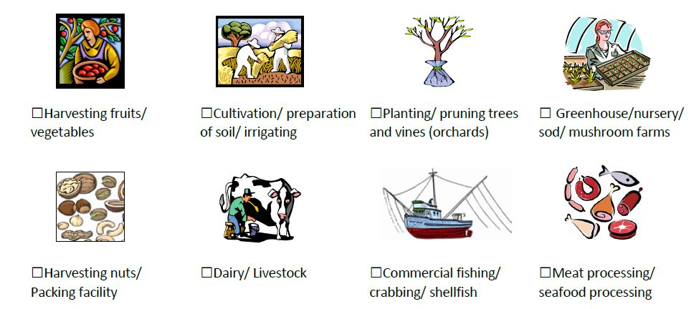

**Other:** __________________________________________________________________

*\*\* Please list the names of all children under 22 years old in your household\*\**

|  |  |  |  |  |
| --- | --- | --- | --- | --- |
| **First Name** | **Last Name** | **School** | **Grade** | **Date of Birth** |
|  |  |  |  |  |
|  |  |  |  |  |
|  |  |  |  |  |
|  |  |  |  |  |
|  |  |  |  |  |



**Programa de Educación Migrante**

Nombre del Estudiante _________________________ Escuela ________________

Nombre del padre________________________ Tel._____________ Fecha_______

1. **¿**Se ha mudado en los últimos tres años para obtener trabajo? **Sí ___ No___**
2. **¿**Ha trabajado, está trabajando o en busca de trabajo de agricultura, pesca, canería, viveros o

empacadoras de carne, frutas o vegetales? **Sí___ No___**

**~**Si su respuesta es ***Sí*** a cualquiera de estas preguntas, por favor complete el resto de la forma**~**

**Por favor, marque los trabajos de agricultura/pesca que hace o ha hecho en el pasado:**

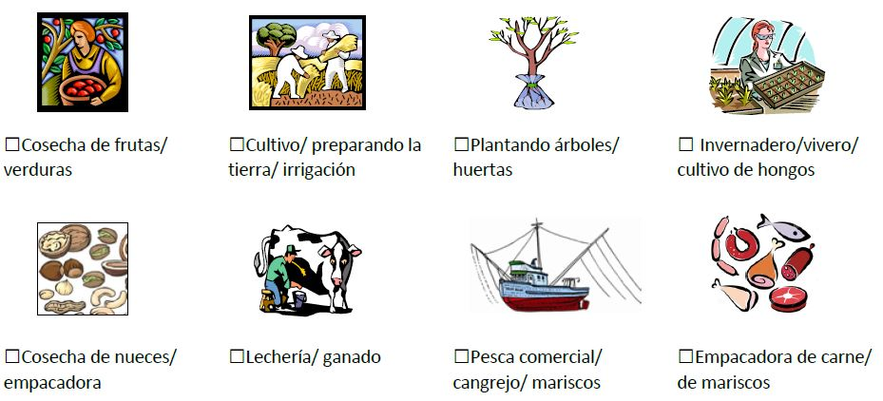

**Otro**: ______________________________________________________________________

*\*\*Favor de escribir los nombres de todos los niños que viven en la casa (menores de 22 años)\*\**

|  |  |  |  |  |
| --- | --- | --- | --- | --- |
| **Nombre** | **Apellido** | **Escuela** | **Grado** | **Fecha de Nacimiento** |
|  |  |  |  |  |
|  |  |  |  |  |
|  |  |  |  |  |
|  |  |  |  |  |